Content Management with ORM stack

Contents

1. Introduction 3
2. Workflow diagram to deploy the stack 3
3. Create stack for Content Management 5
4. Plan the Job 7

Introduction

In business manage, create, and activate various types of content, including websites, documents, videos, and graphic assets, in one cloud native system. With access to a flexible, scalable, and secure content management system, create consistent content in a collaborative environment and make it available to all elements of digital and customer experiences.

Workflow diagram to deploy the stack

Below diagram shows how the Terraform Artifact are applied in the OCI. While creating a ORM stack, using terraform deliverables Init, Plan and Apply is the flow to provision the resource in the OCI. We can have the deliverables in any of below.

- GitLab/GitHub Repo
- Bitbucket
- Can be in folder/.zip in the local disk
- Object Storage Bucket
- Can be in compartment
- Oracle provided Template

Prerequisite:
- Create object storage bucket
- Download access Token from Oci console
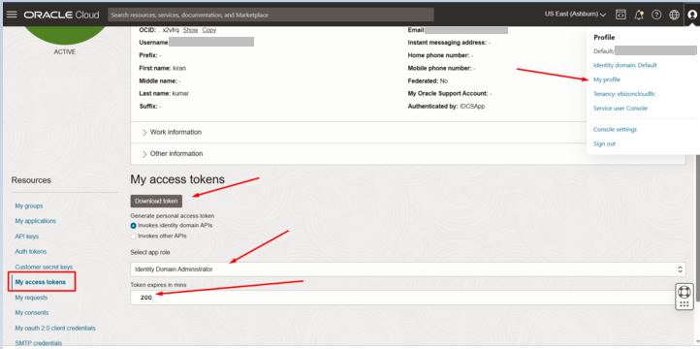

Create stack for Content Management

Go to OCI Console Developer Services Resource Manager Stacks select the compartment Create Stack

My Configuration Folder Browse Select the “Content_management” folder that contains the terraform Upload

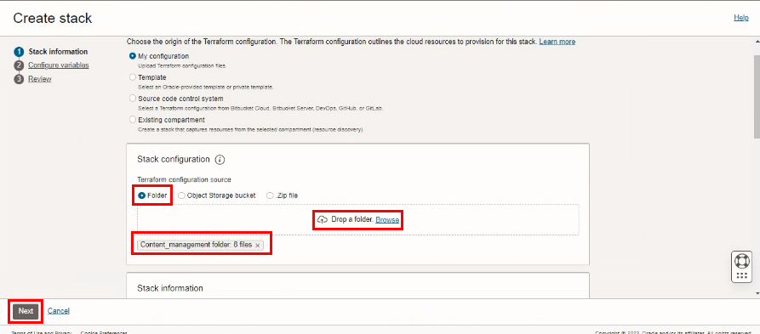

Select the parameters as per the below screen,

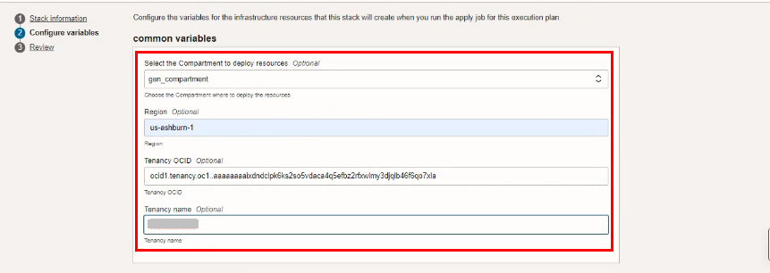

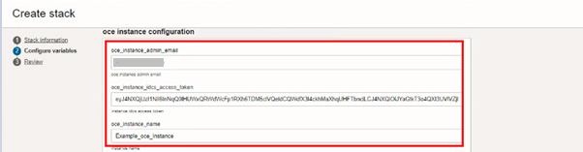

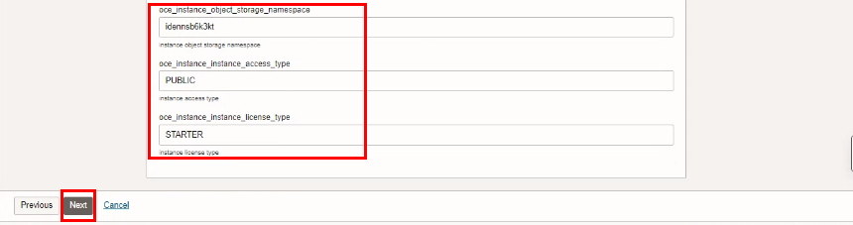

Click “NEXT”

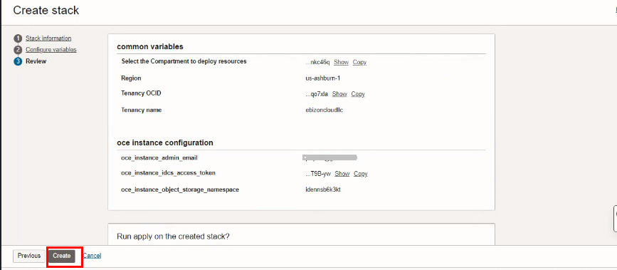
Click “CREATE”

Plan the Job

Click the “Plan”
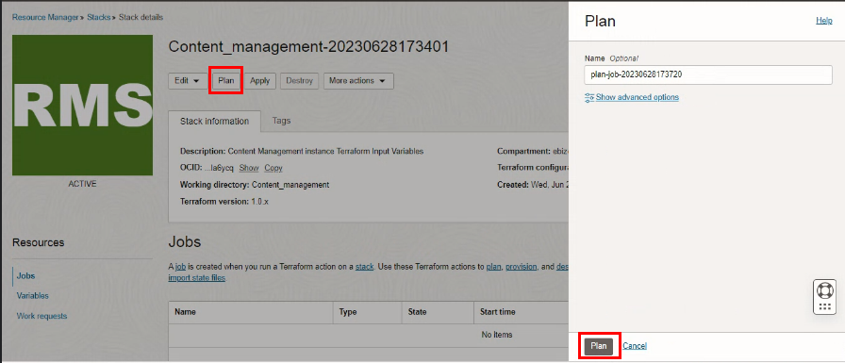

Verify the Plan is successful.

